Source: https://www.linearmotiontips.com/how-to-calculate-velocity/

Trapezoidal move profile
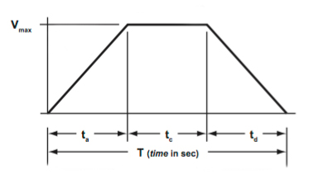Image credit: Womack Machine Supply Co.
A trapezoidal move profile is used when the application needs to accelerate to a maximum velocity and then travel at that velocity for a specified time or distance. Some common processes that use trapezoidal move profiles are machining, dispensing, and painting.
The simplest form of trapezoidal move profile, and the one used in the examples below, is the 1/3, 1/3, 1/3 profile. In this case, 1/3 of the time is used for accelerating, 1/3 is used for constant velocity, and 1/3 is used for decelerating. But if you understand the geometry of the move profile, which is essentially two triangles and a rectangle, you can calculate the necessary parameters regardless of whether the time segments are equal or not.
How to calculate total distance
Recall from the triangular move profile discussion that distance traveled is equal to the area under the curve. The trapezoidal move profile can be treated as three curves, or segments: acceleration (triangle), constant velocity (rectangle), and deceleration (triangle). Therefore, the total distance traveled is the sum of the areas of the three curves:
Now, inserting the formulas for area of a triangle, rectangle, and another triangle:
In each segment, time represents the base, and maximum velocity represents the height, so we get:
Rearranging gives us:
For the 1/3, 1/3, 1/3 profile, t_{a} = t_{c} = t_{d}, and each segment equals 1/3 of the total time, t_{t}. Thus, the equation becomes:
And simplifying, we get:
How to calculate maximum velocity
If maximum velocity needs to be determined, this equation can be rearranged to give:
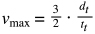
Which can also be expressed as:
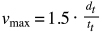

How to calculate acceleration
Because the middle segment (rectangle) is only for constant velocity (zero acceleration), the acceleration can be determined much the same way as for a triangular move profile. In this case, use either the left side triangle (for acceleration) or the right side triangle (for deceleration):
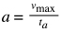
An equation based on distance and time can be derived if we substitute the v_{max} formula from above and insert 1/3t_{t} for t_{a}:
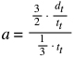
Simplified, acceleration can be expressed as:
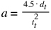
For applications that benefit from a period of constant velocity, a trapezoidal move profile offers the advantage of having a lower maximum velocity than a triangular profile.

